Microwind Experiment
CMOS Inverter Circuit without Capacitor-
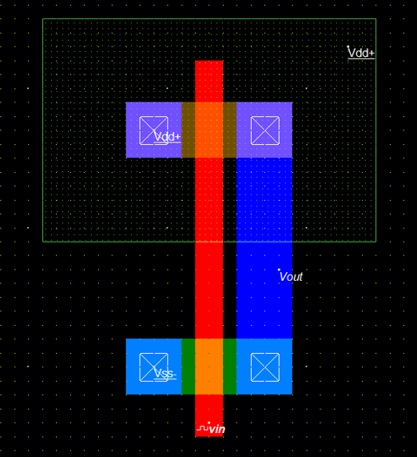
CMOS Inverter Circuit without Capacitor Waveform-
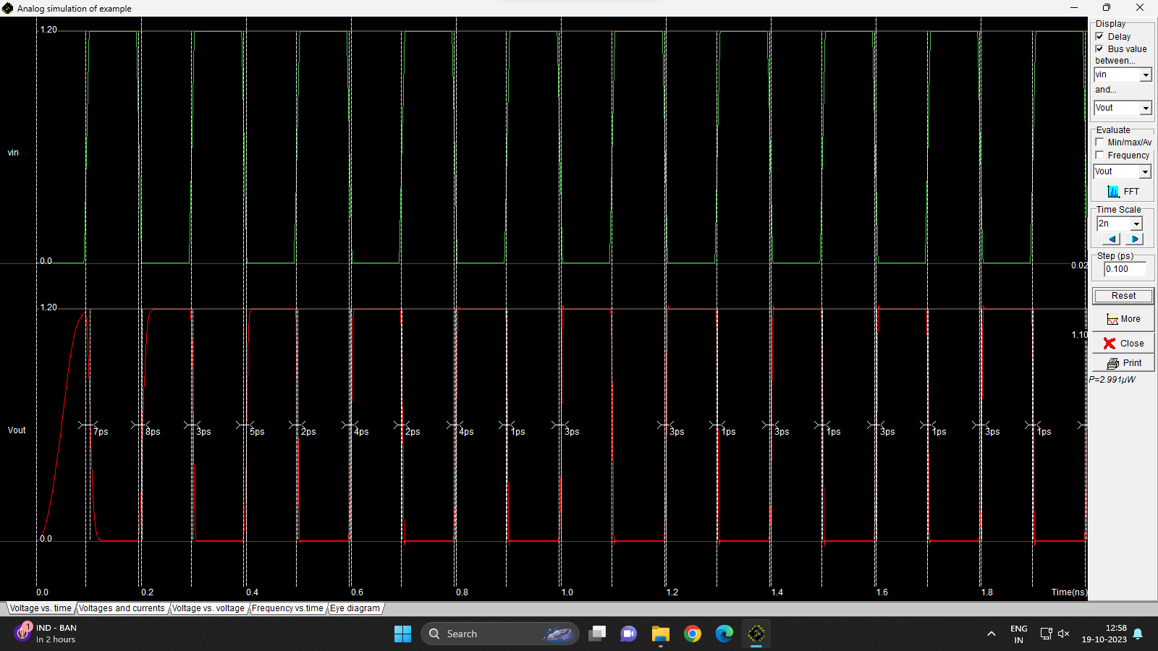

CMOS Inverter Circuit with Capacitor-
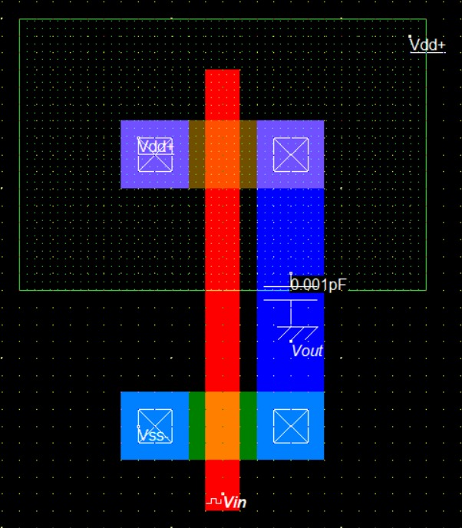
CMOS Inverter with Capacitor Waveform-
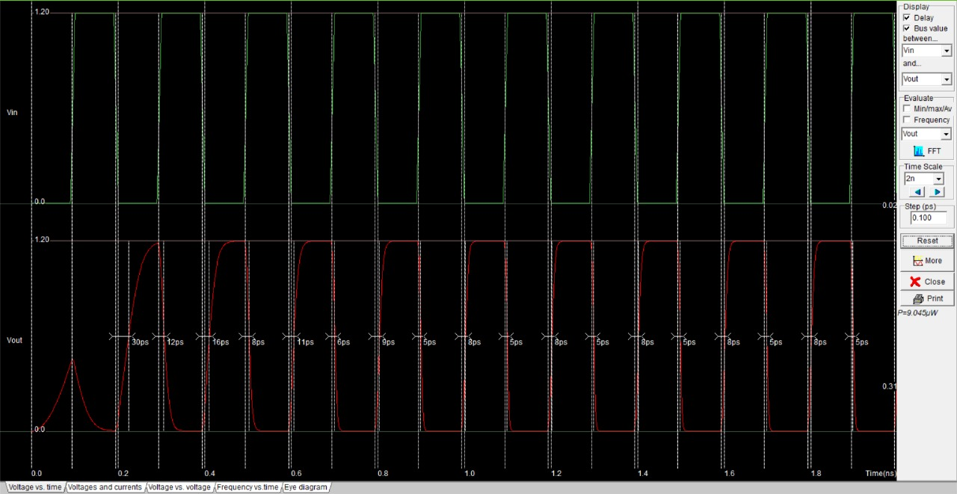

CMOS Inverter Circuit without Capacitor-
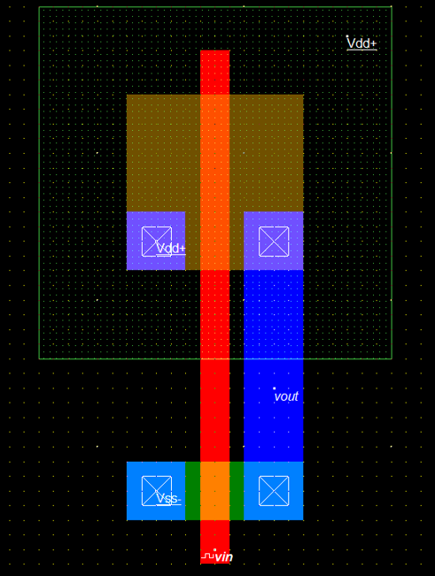
CMOS Inverter Circuit without Capacitor Waveform-
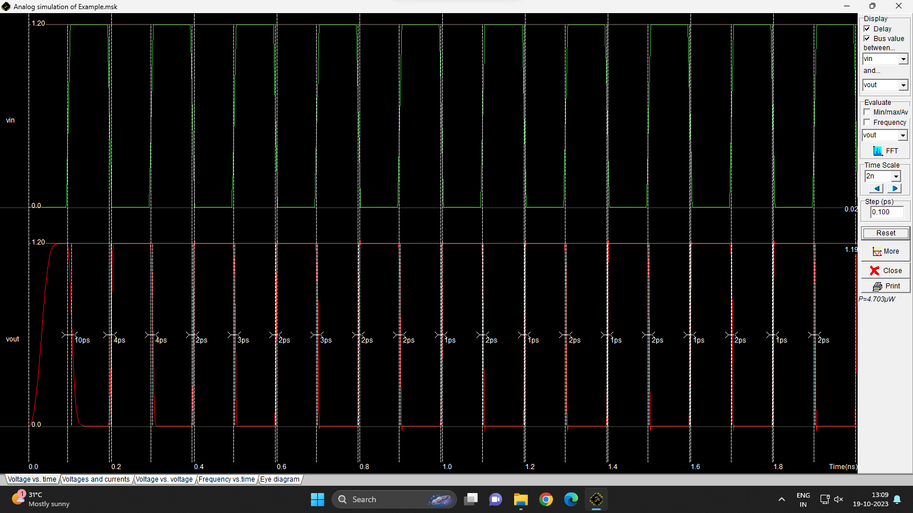

CMOS Inverter with Capacitor Circuit-
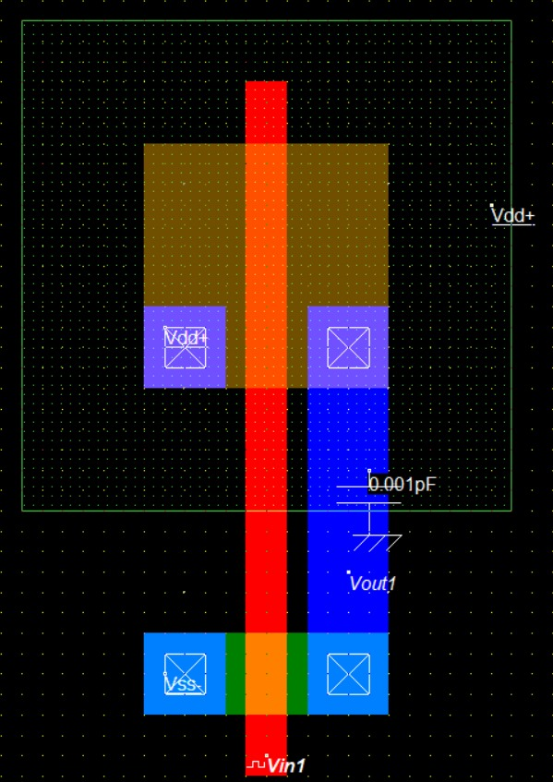

CMOS Inverter with Capacitor Waveform-
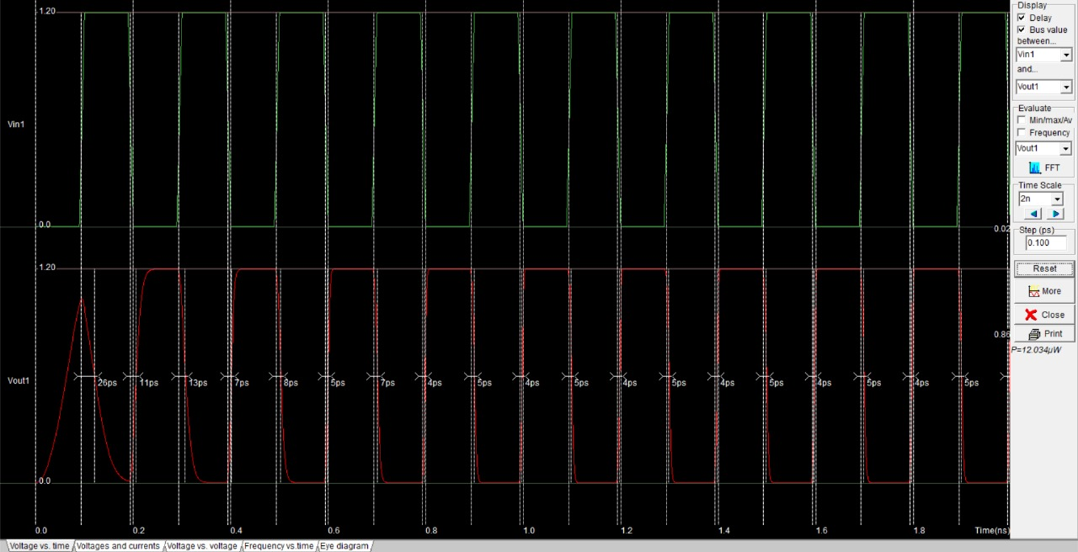

CMOS NAND Gate Circuit-
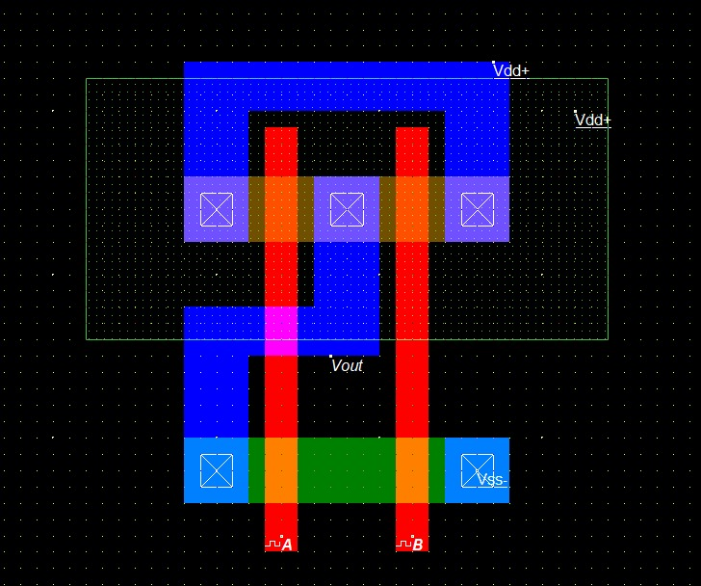

CMOS NAND Gate Waveform-
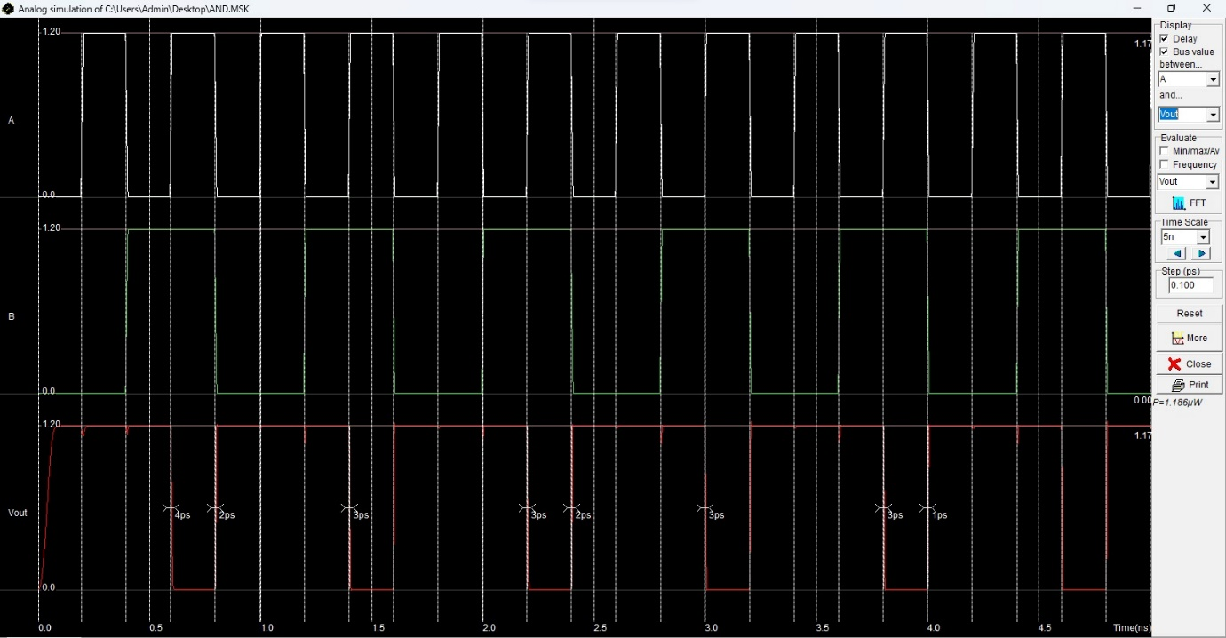

CMOS NOR Gate Circuit-
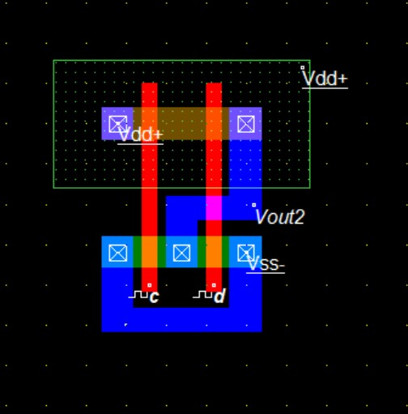

CMOS NOR Gate Waveform-
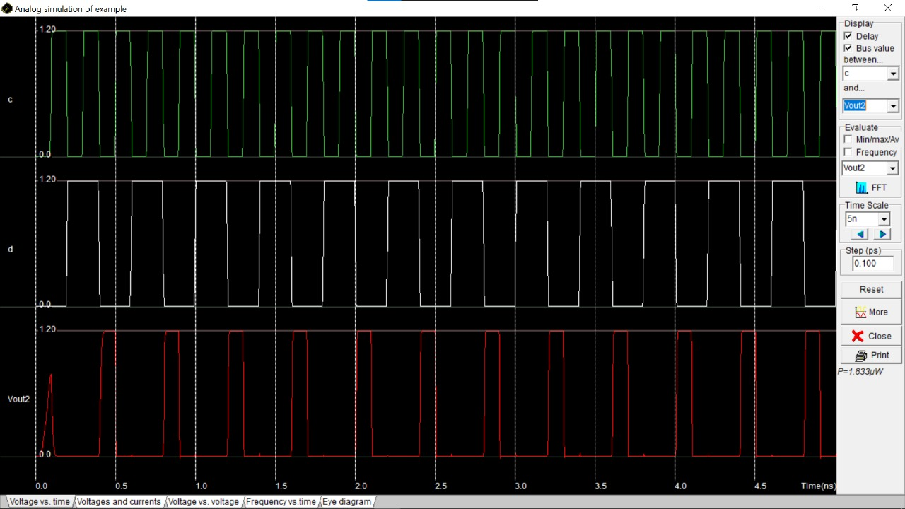

Half Adder Sum-
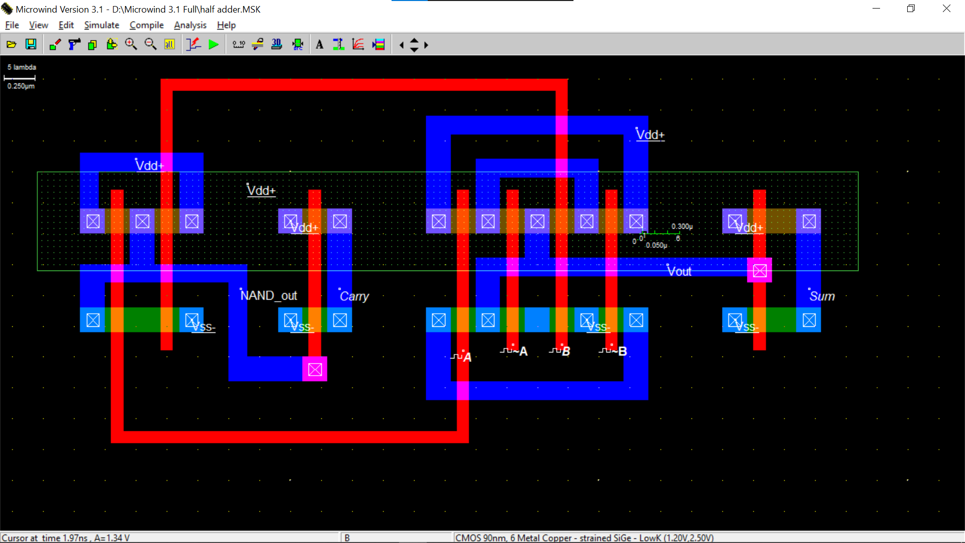
Half Adder Waveform
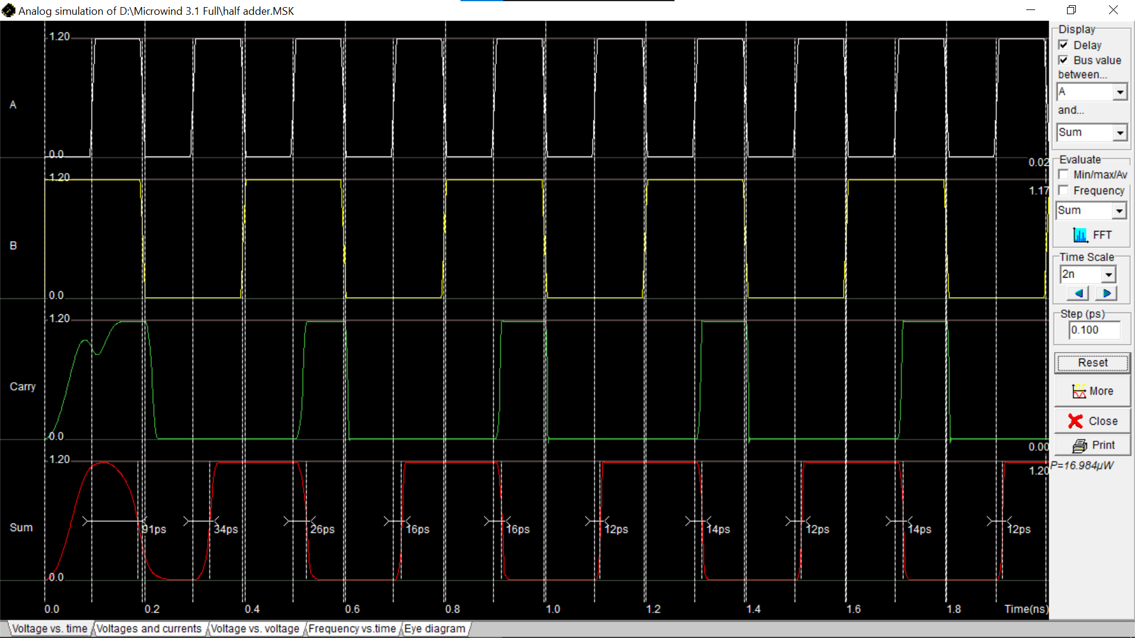-

Full Adder Sum-
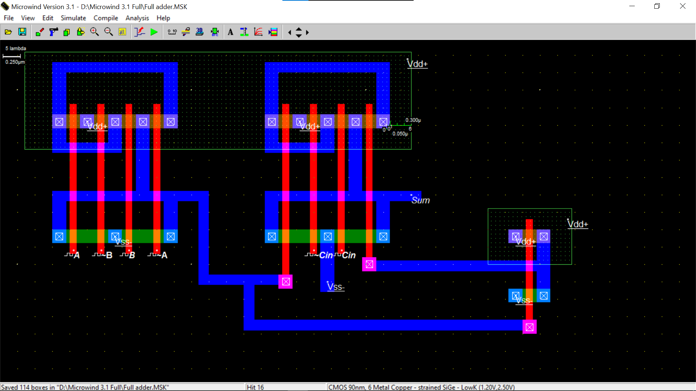

Full Adder Carry-
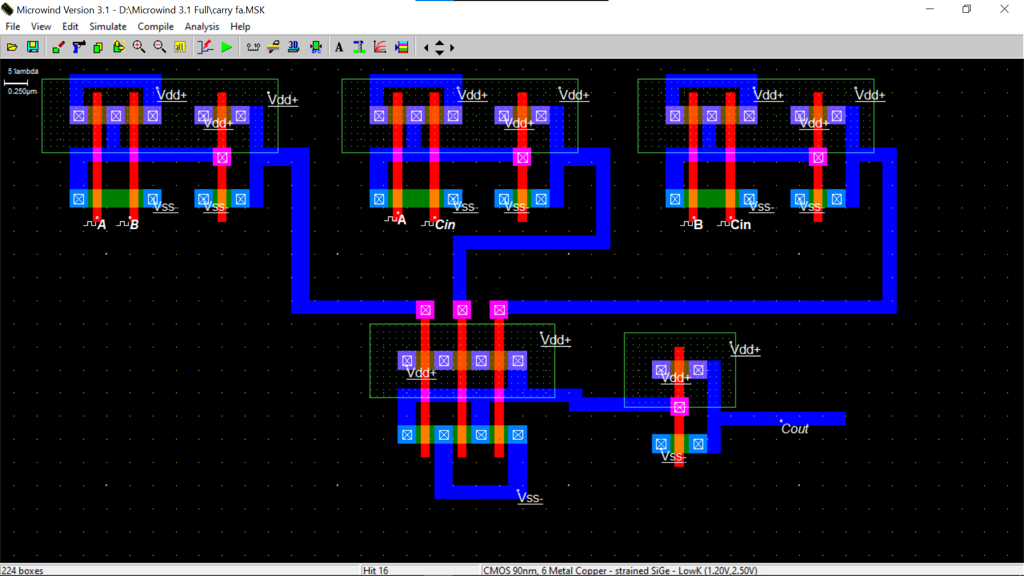

Full Adder Waveform of Sum & Carry –
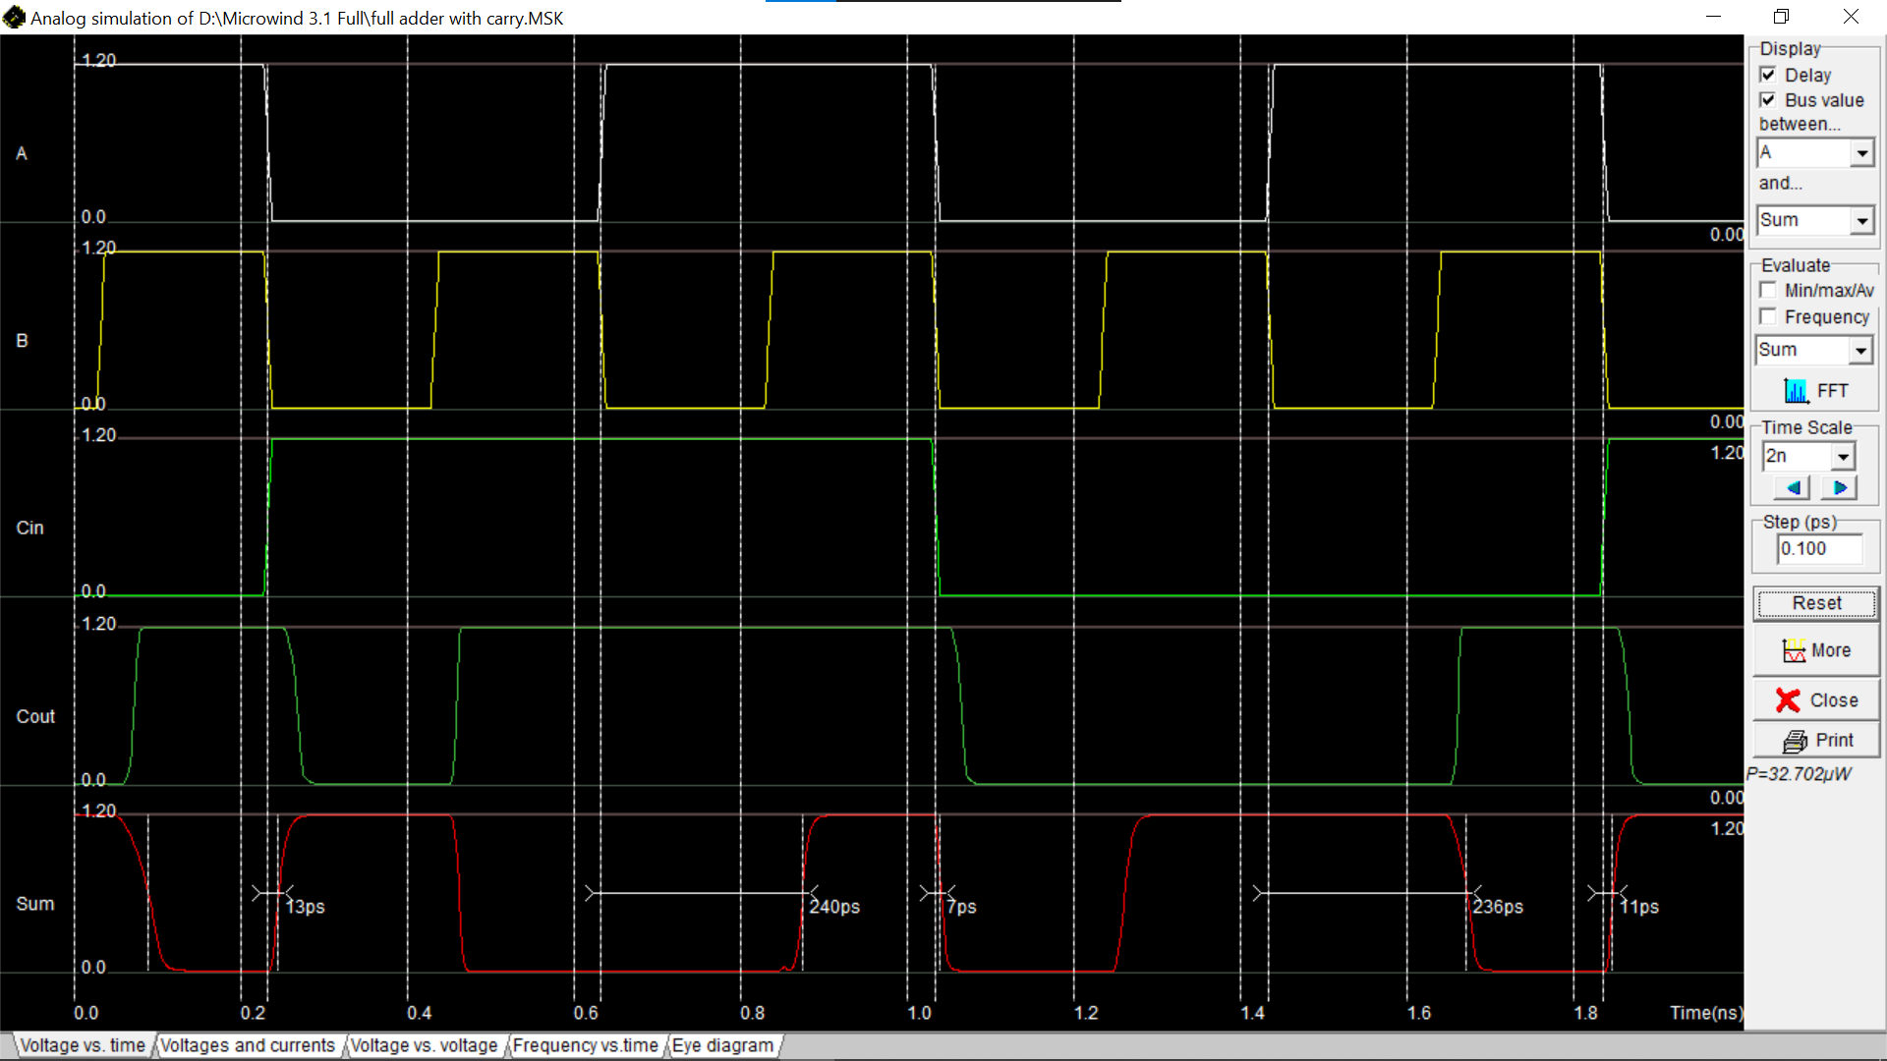
2:1 mux using CMOS –
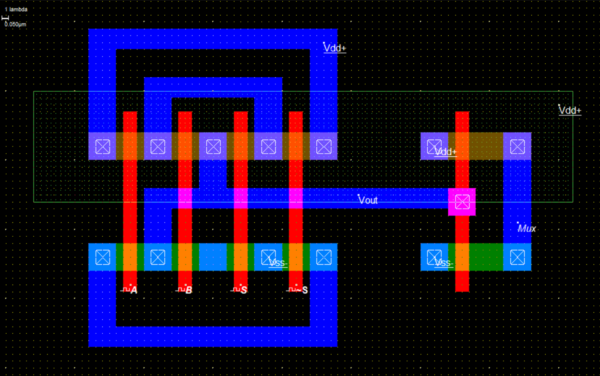
2:1 mux using CMOS Waveform –
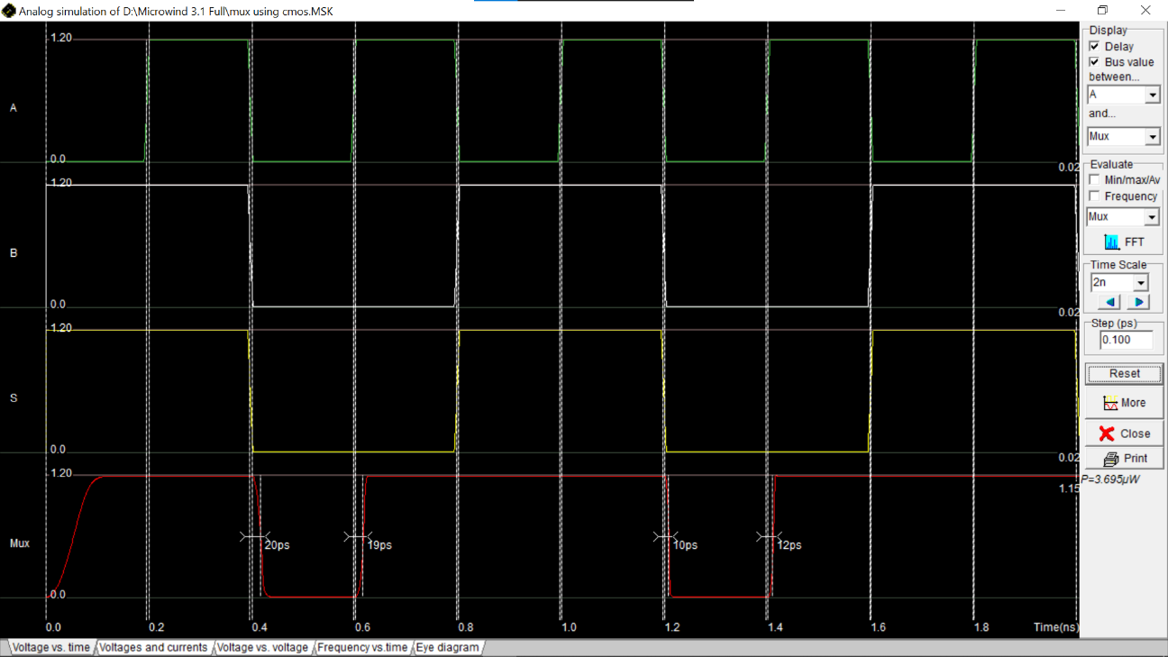

TG (Transmission Gate) –
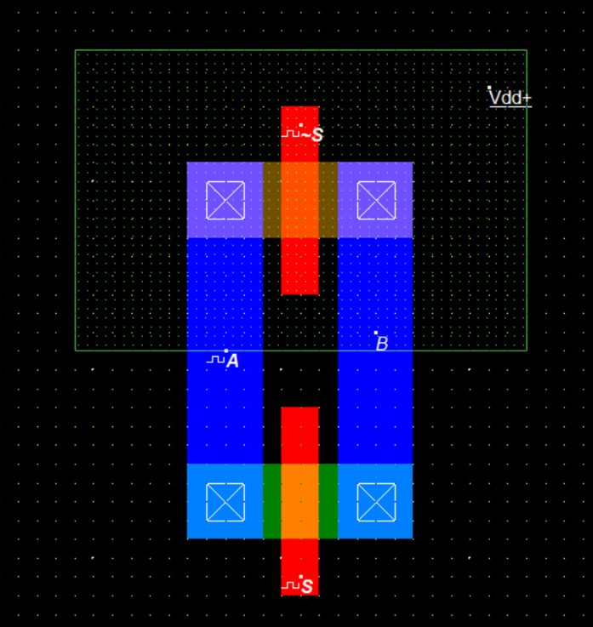

TG (Transmission Gate) -
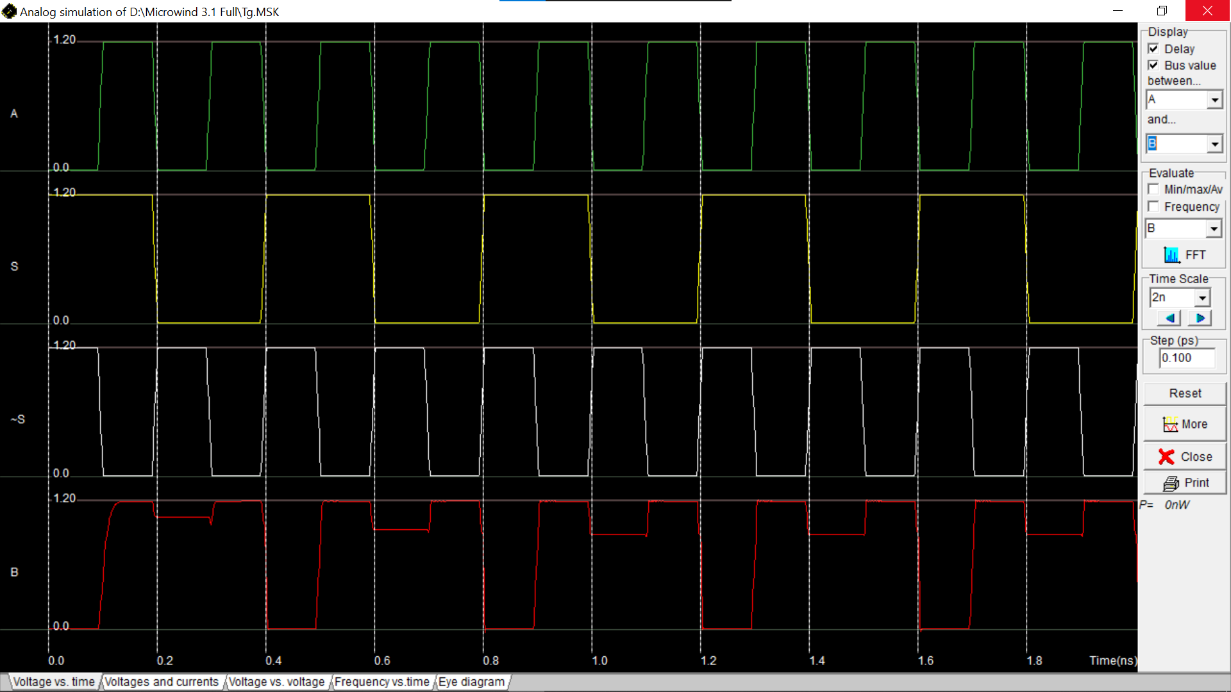
2:1 mux using TG –
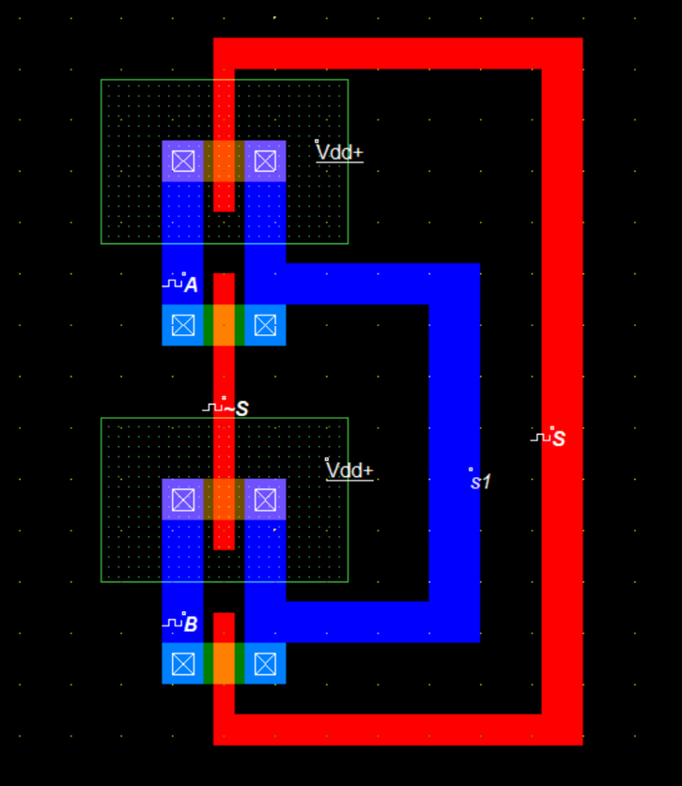

2:1 mux using TG -
